Step 01.
First you need to login

Then type this http://192.168.100.22/radiusmanager/user.php link in your browser address field

This will take you to User Control Panel

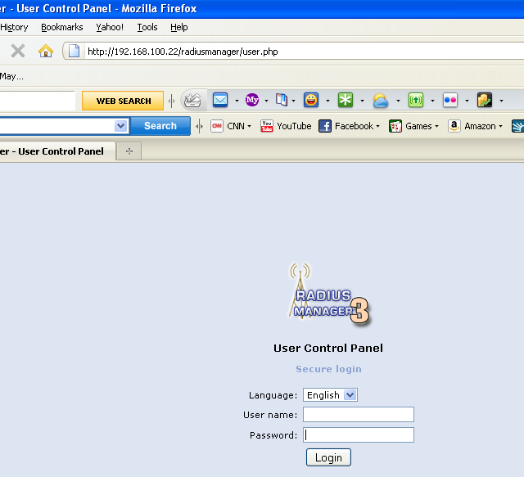

Step 02 .
Thereafter you will need to put your User Name and Password

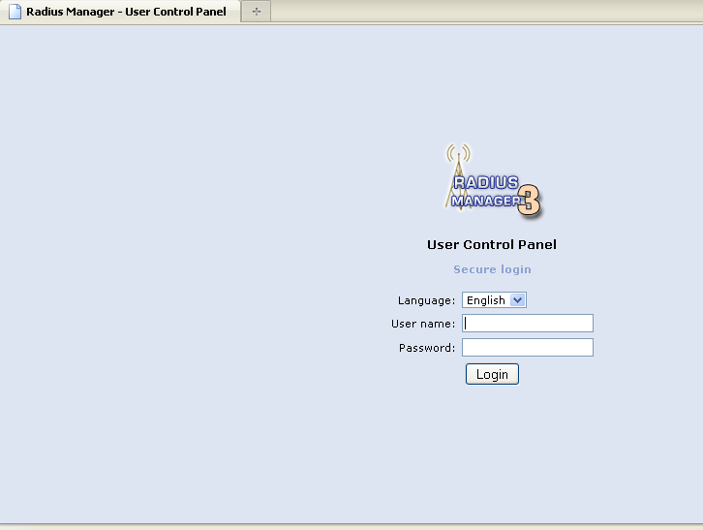
Enter Your User Name
Enter password
Click here

Step 03.
Now click the change password link

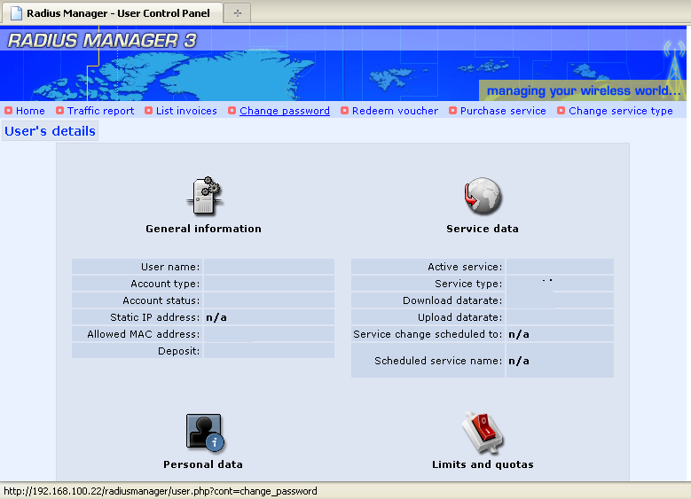
Click this link

Step 04.

Then you will get Change Password Window

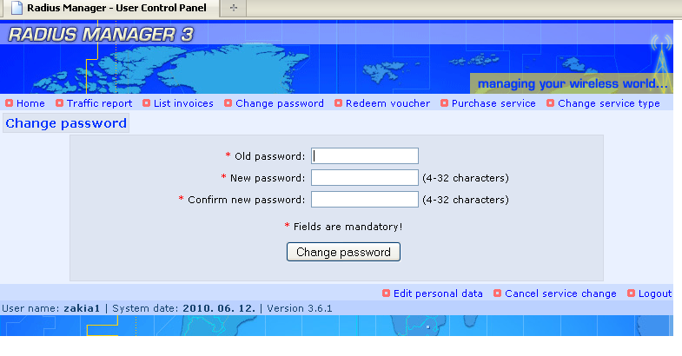
Put your Old password
Put your new password
Enter the Same password again
Press this button

This is for Logout

Next you need to Logout

Now you need to put your new password to connect the internet

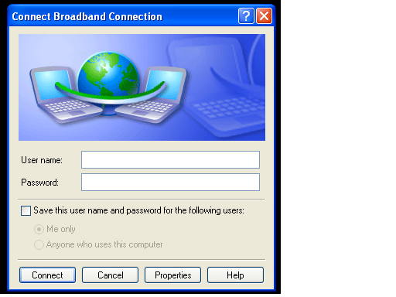
Enter your User Name
Enter your New Password

This is the way to change your password and keep changing every month

To Edit user profile you need to repeat step 1, step 2, step 3

Then

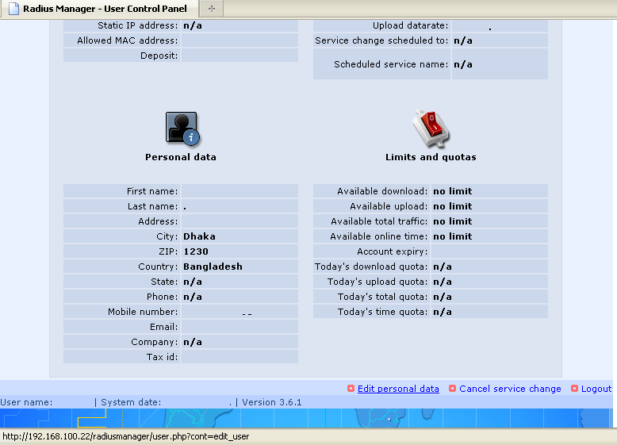
To edit your profile click this link

Step 05.

Edit every (*)Star marked field and then click Submit button

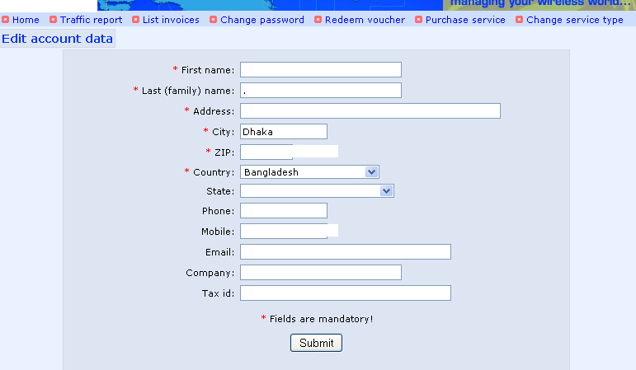

Click this Button to Save

After that press logout button

